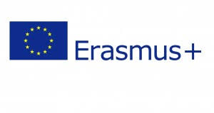
Dear Parents,
Could you please take a few minutes to fill out this questionnaire regarding our participation in Erasmus +. Thank You.

Erasmus+ Questionnaire – Parents
- Have you ever heard of Erasmus+ before now? Yes No

- What is your Native Language / Language spoken in the home?

- Would you like your child to learn some basic words from partner schools? Yes No

- Does your child have internet access at home? Yes No

- Can your child use the internet at home for educational purposes? Yes No

- Would you be willing to allow your child to practise language skills online? Yes No

- Do you think participating in Erasmus+ is a positive aspect of school life? Yes No

Thank you for completing this questionnaire, Please return to the school before Friday 19th Oct 2018,

